To:

You are invited to the Palmer’s Gulch shooting Match to be held on July 2 to July 6, 2020.

This match is being held at the Heffley Creek Gun Club which is 25 kilometers Northeast of Kamloops British Columbia. The legal land description for the range is West 1.2 of Section 19, Township 22, Range 16, West of 6th Meridian, Kamloops Division of Yale District.

If I can be of any further assistance please do not hesitate to call me at 1-250-318-7060, or Email me at cgblues@shaw.ca.

Daryl Buddecke

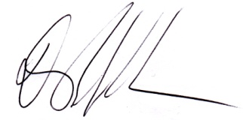
Registrar
Palmer’s Gulch
Heffley Creek Gun Club

